Mental Lexicon

What is Mental Lexicon
# Source: Chatgpt (GPT-4-turbo) at [7/29/2025]
The Mental Lexicon refers to the internalized dictionary of words and morphemes stored in a speaker's long-term memory. It contains everything we know about words: their form, meaning, pronunciation, grammar, and usage. It is not organized alphabetically like a physical dictionary but is instead structured based on associations, frequency, and context.

🔹 Key Features of the Mental Lexicon:
# Source: Chatgpt (GPT-4-turbo) at [7/29/2025]
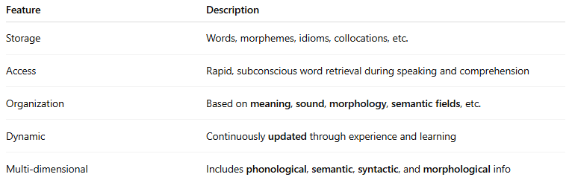
Feature | Description
Storage | Words, morphemes, idioms, collocations, etc.
Access | Rapid, subconscious word retrieval during speaking and comprehension
Organization | Based on meaning, sound, morphology, semantic fields, etc.
Dynamic | Continuously updated through experience and learning
Multi-dimensional | Includes phonological, semantic, syntactic, and morphological info

🔹 What Does the Mental Lexicon Contain?
# Source: Chatgpt (GPT-4-turbo) at [7/29/2025]
- Phonological form: how the word sounds (e.g., /dɒg/)
- Orthographic form: how the word is written (dog)
- Syntactic info: word class (noun, verb), subcategorization
- Semantic meaning: concept associated with the word (a domestic animal)
- Morphological data: base forms, inflections (dog → dogs)
- Collocations & idioms: barking up the wrong tree, hot dog
- Frequency info: more frequent words are retrieved faster

🔹 Examples of Mental Lexicon Use:
# Source: Chatgpt (GPT-4-turbo) at [7/29/2025]
- When you hear the word “run”, your mental lexicon instantly links it to:
  - its pronunciation
  - meanings (move fast, operate, flow)
  - past tense (ran)
  - noun form (a run)
  - syntactic roles and idiomatic use (run out of time)

🔹 Mental Lexicon vs Dictionary Lexicon:
# Source: Chatgpt (GPT-4-turbo) at [7/29/2025]
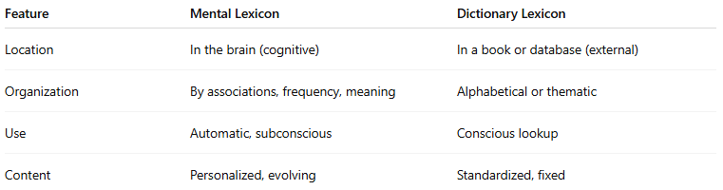
Feature | Mental Lexicon | Dictionary Lexicon
Location | In the brain (cognitive) | In a book or database (external)
Organization | By associations, frequency, meaning | Alphabetical or thematic
Use | Automatic, subconscious | Conscious lookup
Content | Personalized, evolving | Standardized, fixed

🔹 Research Fields:
# Source: Chatgpt (GPT-4-turbo) at [7/29/2025]
- Psycholinguistics
- Neurolinguistics
- Cognitive science
- Second language acquisition

